Task of Cloud-Front  
  
1) **Configure VPC peering in cross regions.**

Steps:

In Region 1 (us-east-1):

Go to VPC Console.

Click on Peering Connections > Create Peering Connection.

Enter:

Name tag: us-east-to-eu-west

VPC Requester: Select your VPC in us-east-1.

VPC Accepter: Choose "Another account or region", and then:

Account: Your AWS Account ID

Region: eu-west-1

VPC ID: Accepter VPC ID from eu-west-1

🡪Created Vpc  
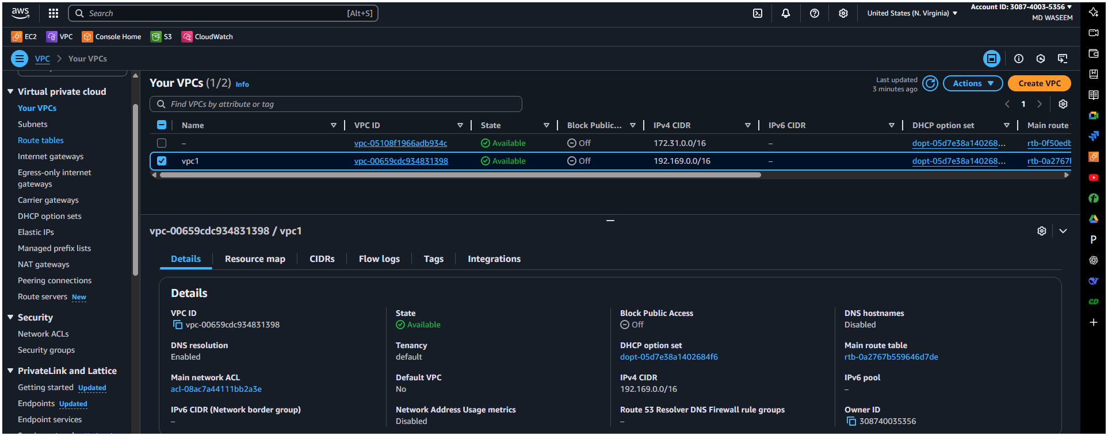  
🡪Subnet  
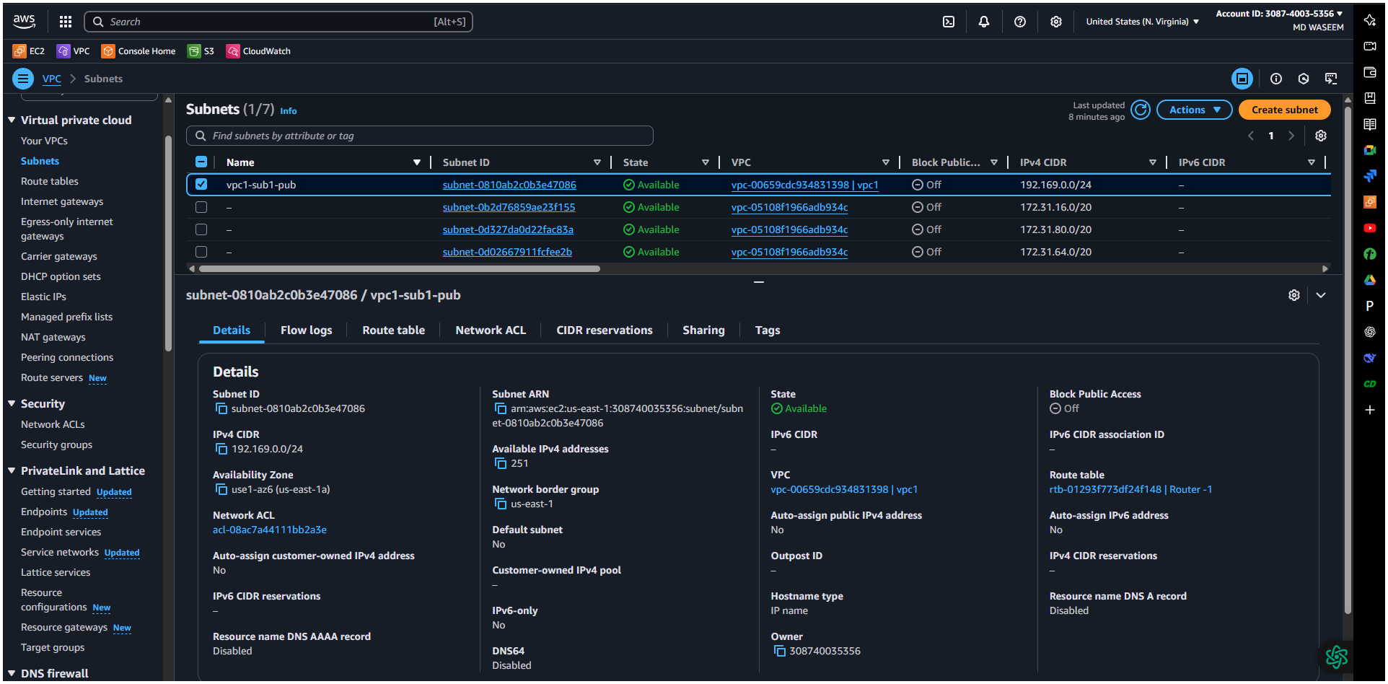  
🡪created Route Table  
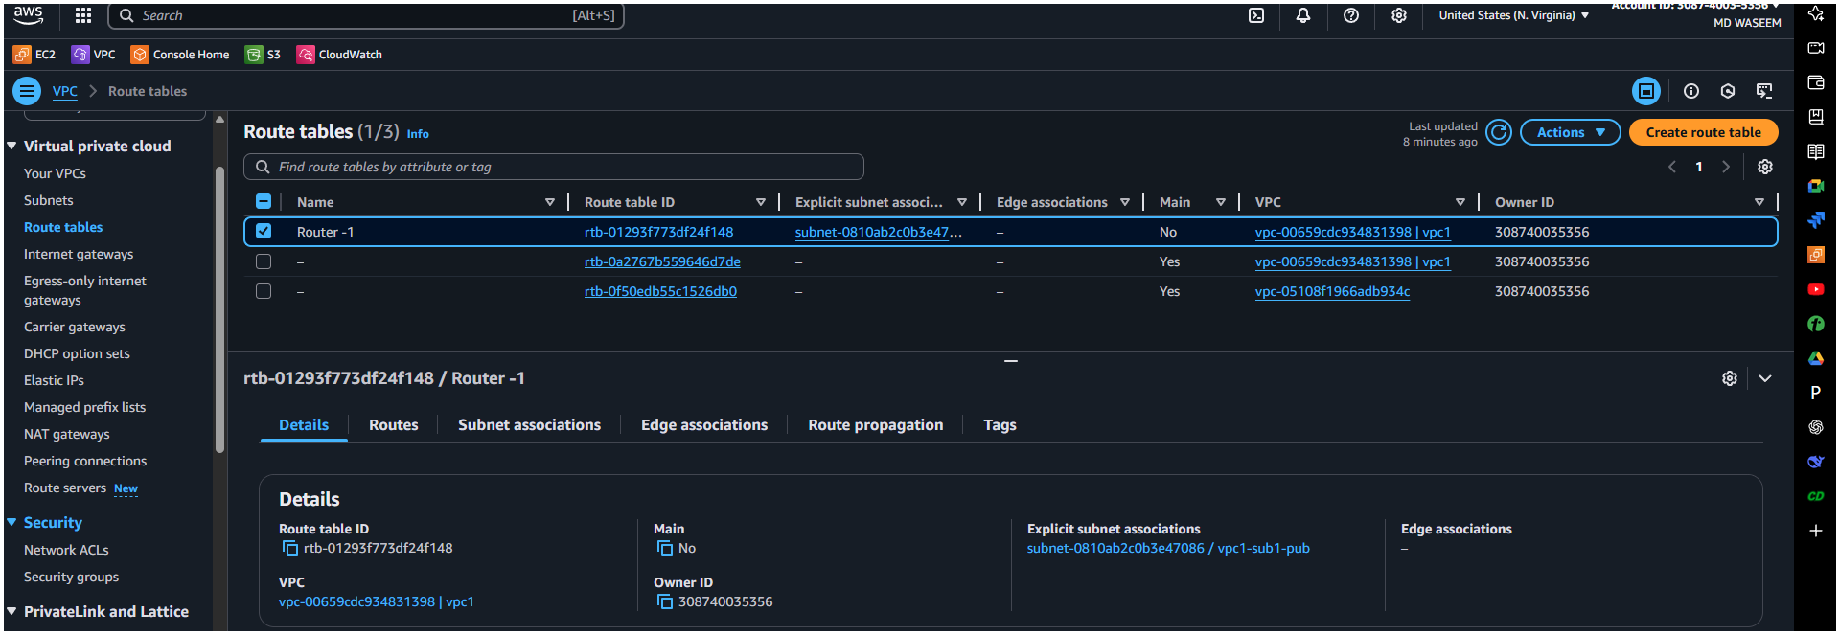  
🡪Internet Gatways   
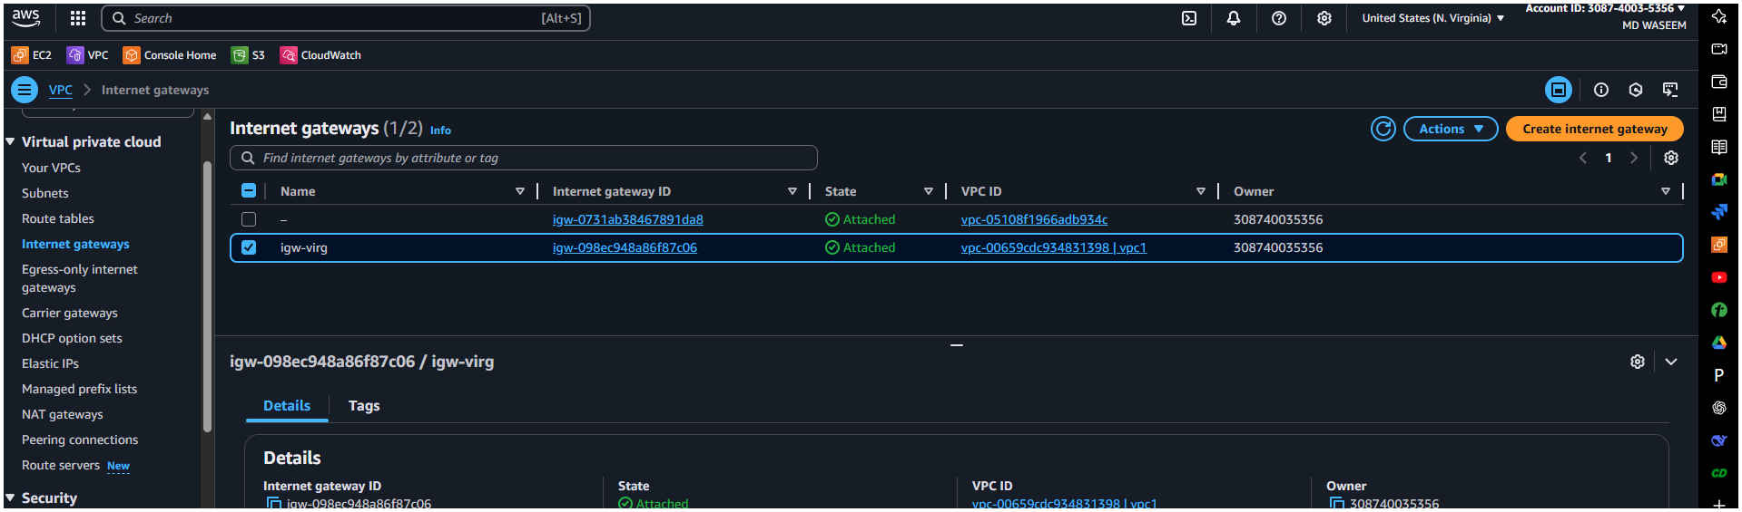  
🡪Requester Side  
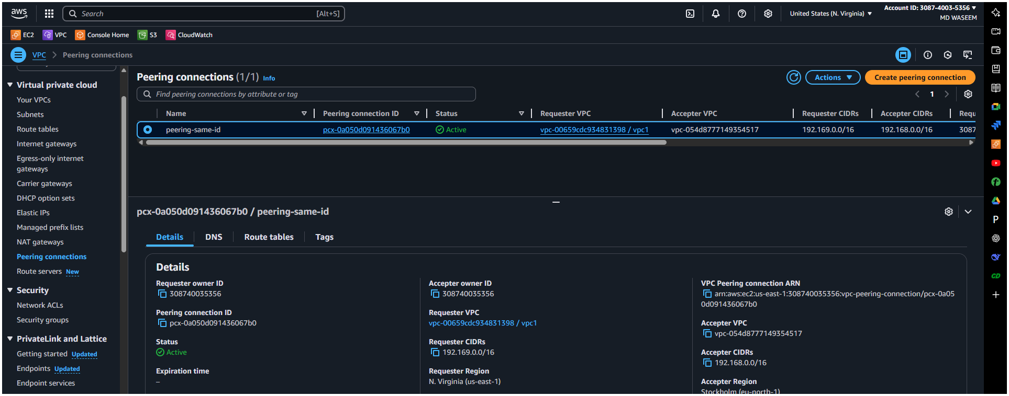  
  
Click Create Peering Connection.

🔹 In Region 2 (Europe (Stockholm):

Go to VPC Console > Peering Connections.

Select the pending peering request.

Click Actions > Accept Request.

🔹 Update Route Tables in both VPCs:

Go to Route Tables > Choose the route table for each VPC.

Add a new route:

Destination: CIDR block of the other VPC.

Target: The VPC peering connection ID.

✅ Result: Now the two VPCs can securely communicate.  
  
🡪created Vpc from another region

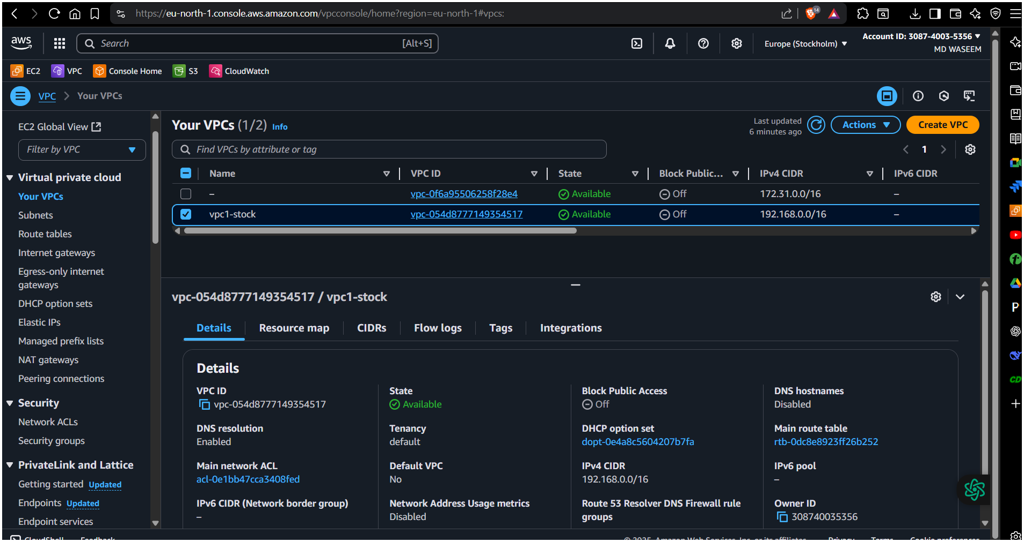  
🡪subnet  
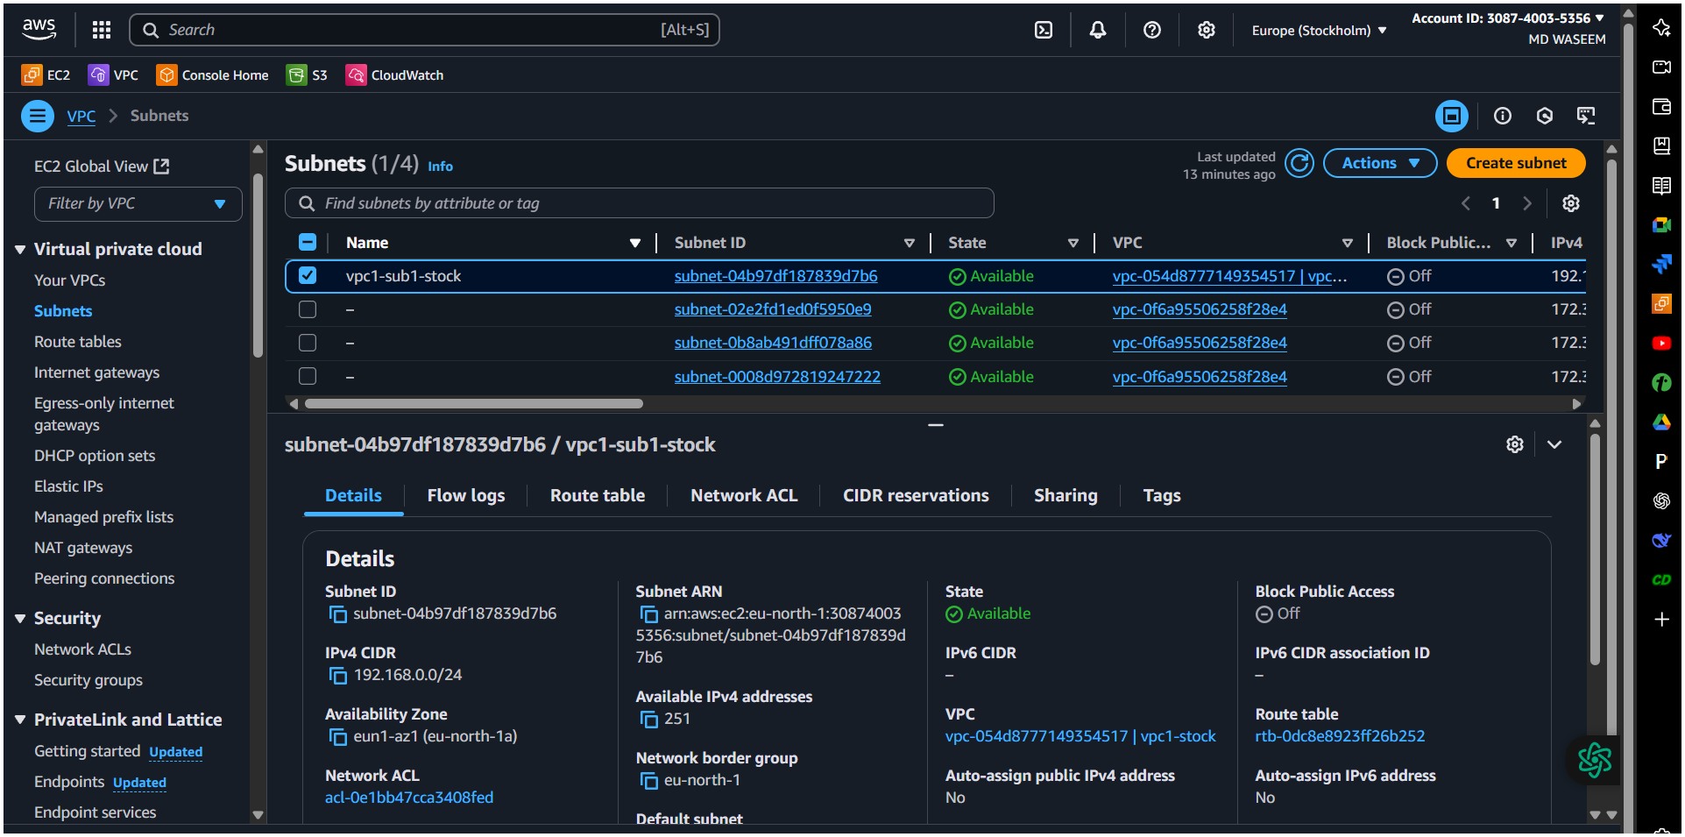  
🡪Route Table  
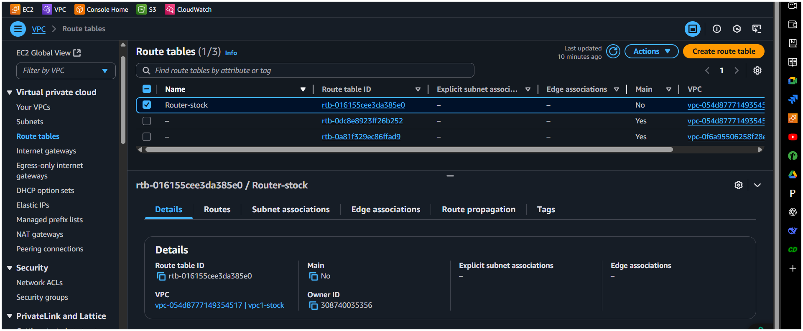

🡪Internet Gatways  
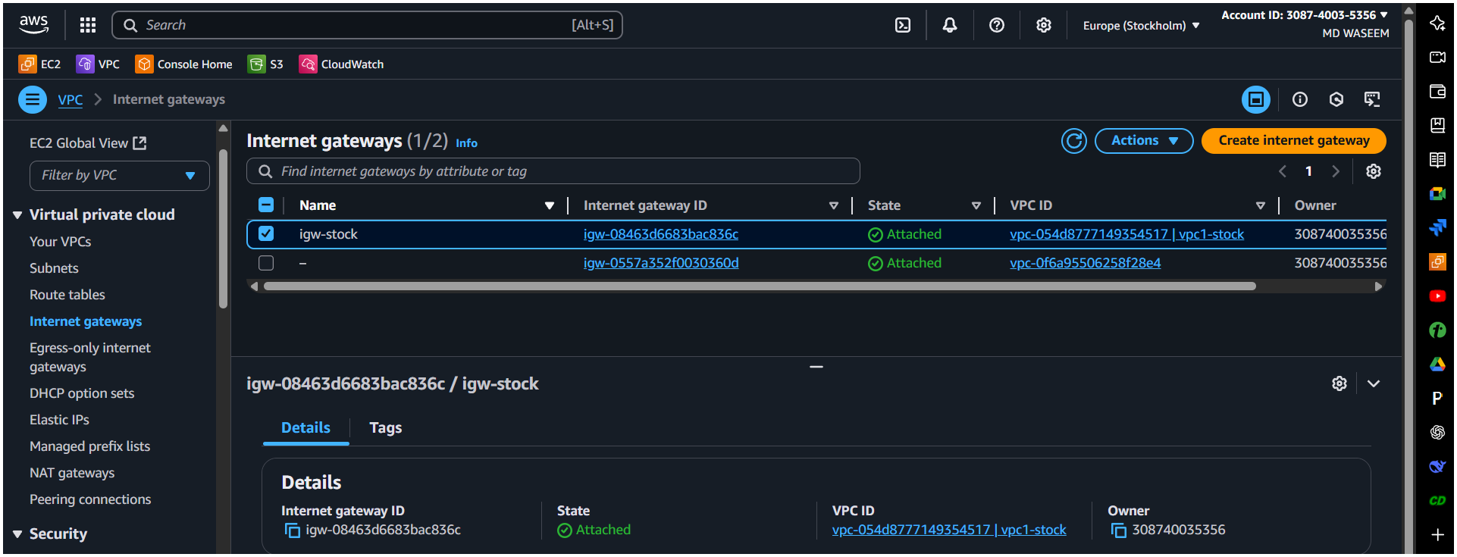  
🡪Accepter side

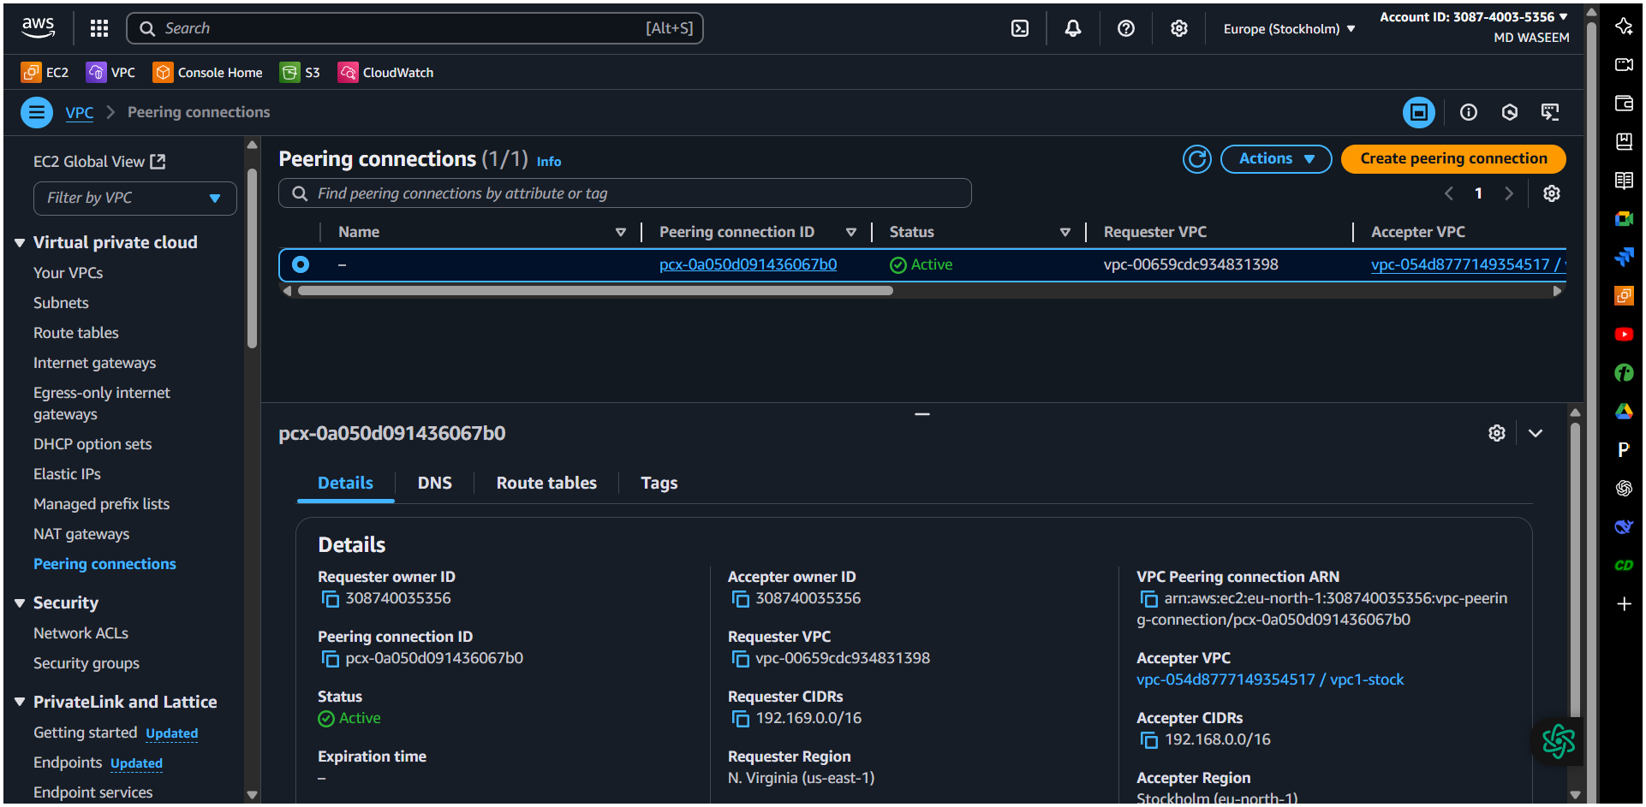

2) Purchase one domain from Crazy Domains.  


3) Deploy static website in s3.  
Host your website (HTML files) on Amazon S3.

📋 Steps:

Go to S3 Console > Create bucket:

Name: cloud-front-testingg -bucket

Region: Same as where you’ll host your content

Uncheck: “Block all public access”

Upload your index.html file.

Go to Properties > Enable Static Website Hosting:

Enable

Index document: index.html

Copy the S3 static website URL provided.

✅ Result: Your website is now available on an S3 public endpoint like:

🡪 You may get this error to overcome with we need to add this bucket policy

click your bucket then you get a option 🡪 Permission 🡪 Bucket policy 🡪 Edit it 🡪Add this policy

{

"Version": "2012-10-17",

"Statement": [

{

"Sid": "PublicReadGetObject",

"Effect": "Allow",

"Principal": "*",

"Action": "s3:GetObject",

"Resource": "arn:aws:s3:::cloud-front-testingg/*"

}

]

}  
  
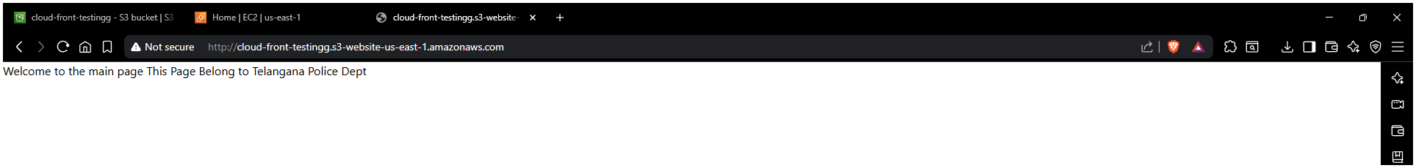

4) Create CDN and attach one SSL certificate.|  
  
📋 Steps:

Request SSL Certificate:

Go to AWS Certificate Manager (ACM) > Request a certificate.

Choose: Request a public certificate.

Enter: mycoolwebsite.com

Choose DNS Validation.

It will give you a CNAME record to add.

Go to GoDaddy DNS Management > Add the CNAME.

Wait until it says Validated.

Create CloudFront Distribution:

Go to CloudFront Console > Create Distribution.

Origin:

Origin domain: Select your S3 bucket’s website endpoint.

Origin Access: Leave as is (for public bucket).

Viewer:

Alternate Domain (CNAME): mycoolwebsite.com

SSL Certificate: Choose the ACM certificate

Viewer Protocol Policy: Redirect HTTP to HTTPS

Create the distribution.

Wait ~10-15 minutes for the distribution to finish deploying.

✅ Result: Your site is now cached globally and accessible with HTTPS (SSL).  
  
🡪Creating CloudFront Distribution   
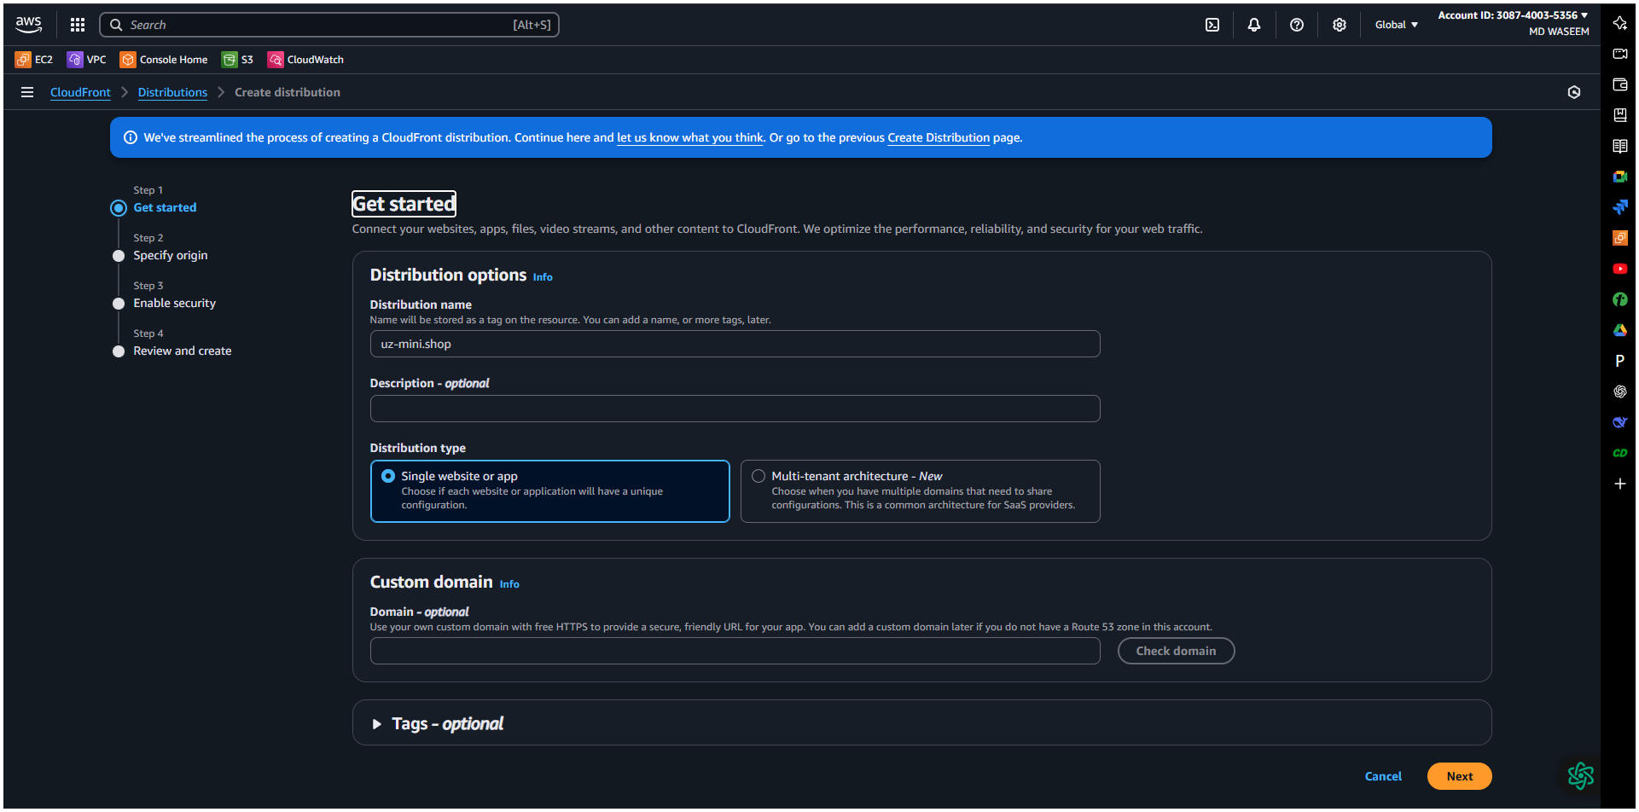  
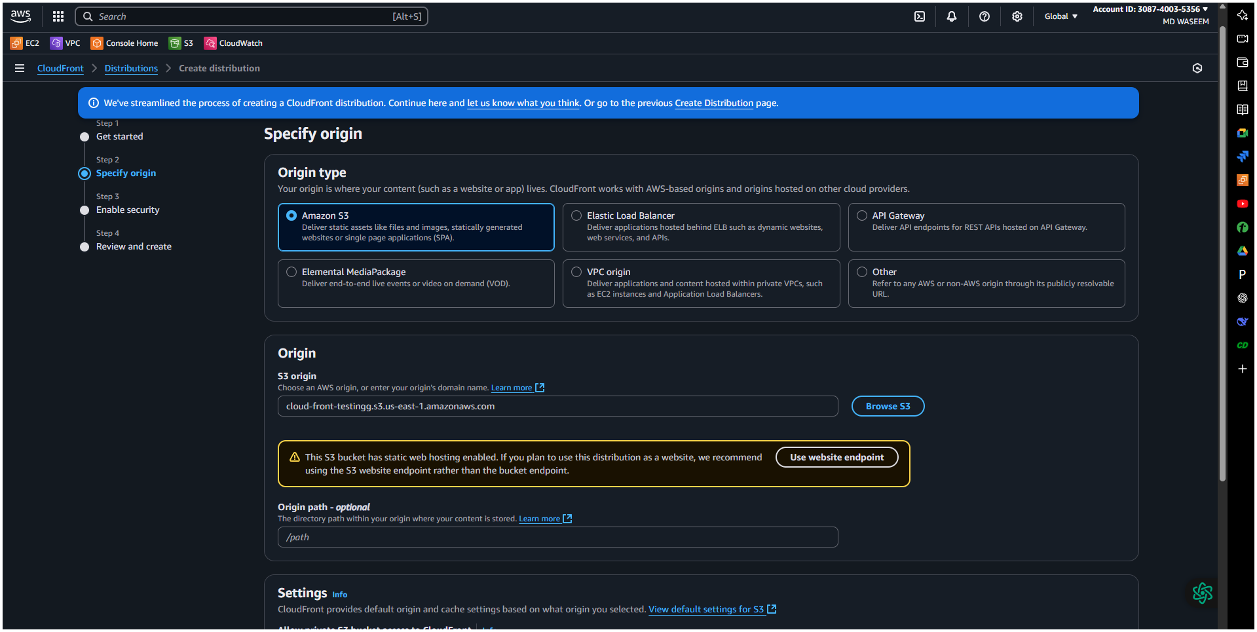

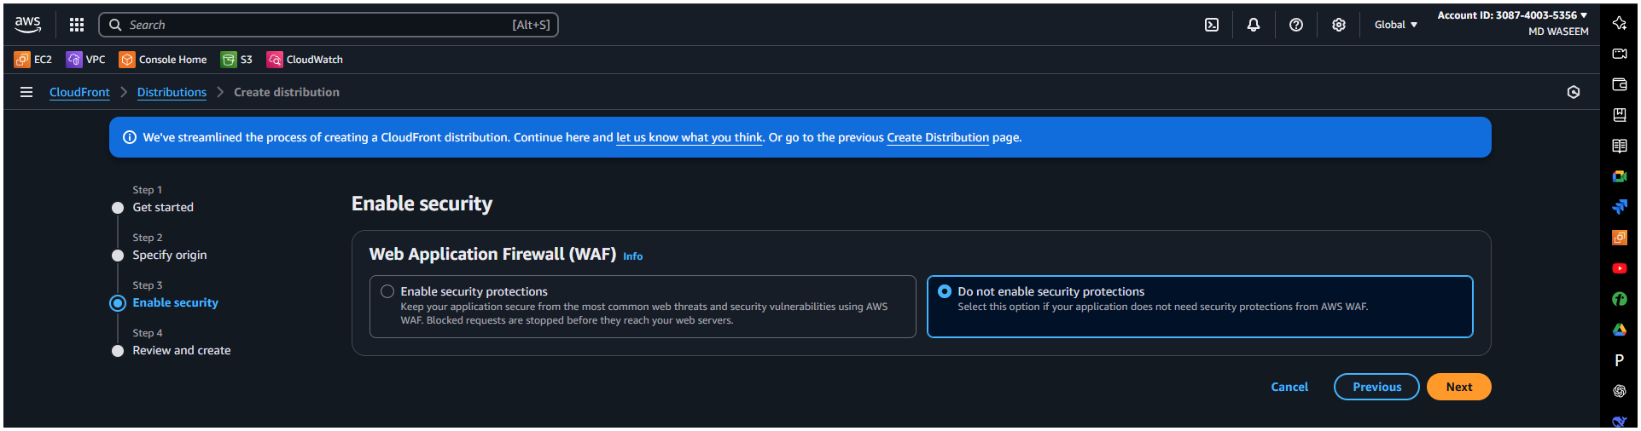  
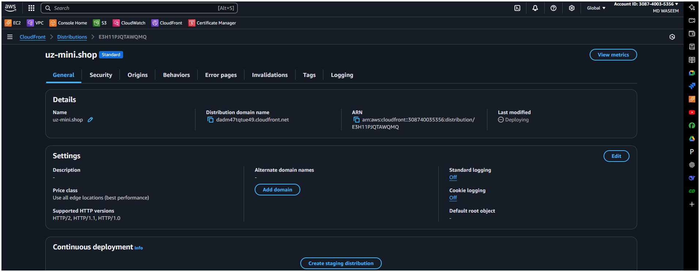

🡪Go to your domain 🡪Dns setting 🡪 add record 🡪select cname record 🡪 Paste the cname , cvalues from your [Certificates manager from Aws console]  
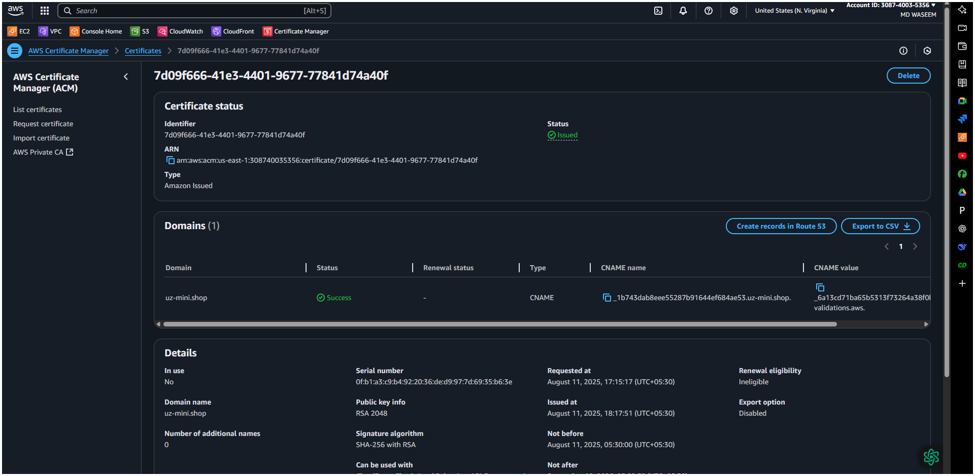

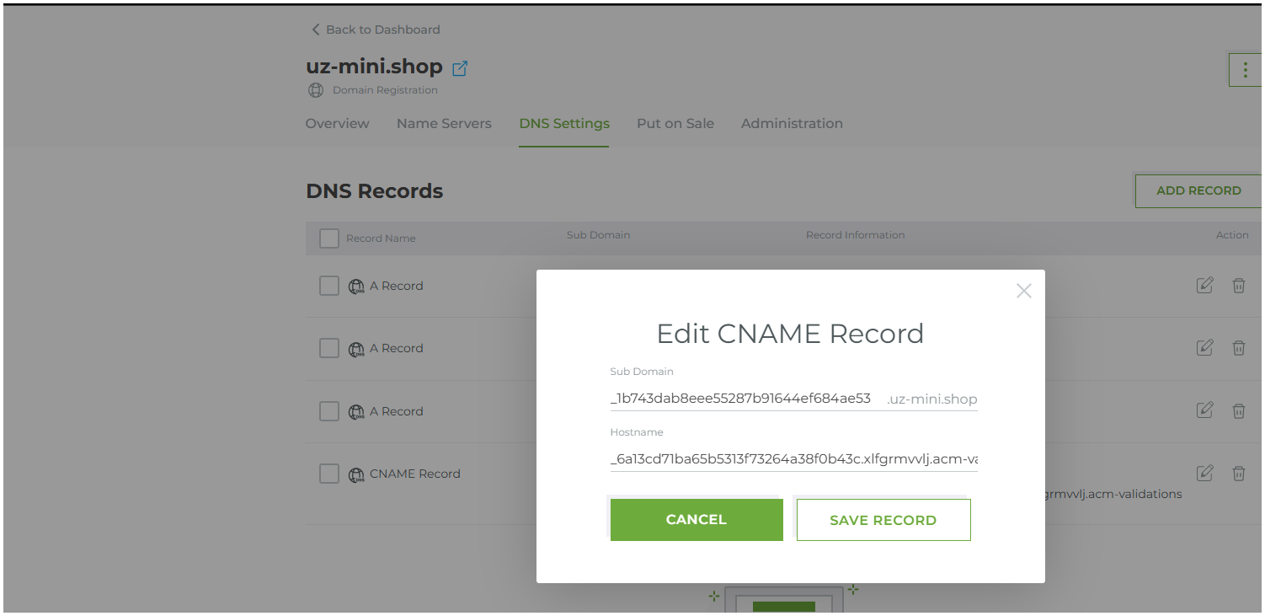

🡪Added cname and cvalue in Domain DNS setting  
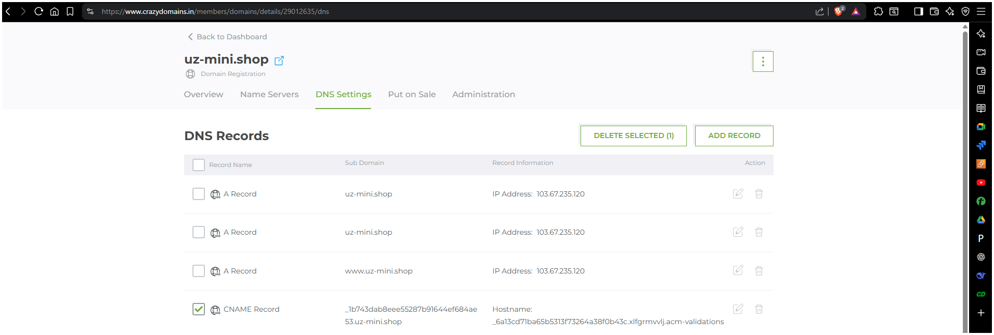

🡪Certificate status check ✅  
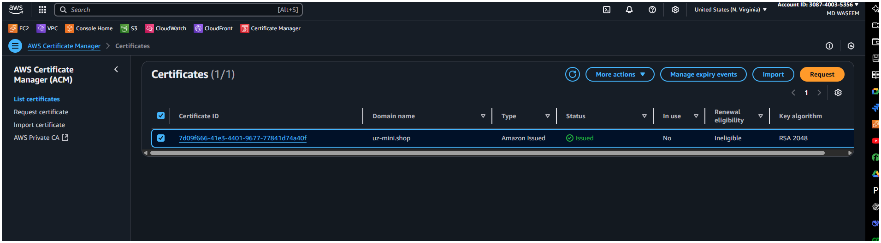



5) Create Route53 hosted zone and MAP the domain with CDN.  
  
  
📋 Steps:

🔹 Create Hosted Zone:

Go to Route 53 Console > Hosted Zones > Create hosted zone:

Domain Name: mycoolwebsite.com

Type: Public Hosted Zone

Update GoDaddy Name Servers:

After hosted zone creation, copy the NS records (name servers).

Go to GoDaddy DNS > Change Nameservers > Set to custom.

Paste the four NS records from Route 53.

Create Record in Route53:

Inside the hosted zone:

Click Create Record:

Name: Leave blank (to use the root domain)

Type: A (Alias)

Value: Select your CloudFront distribution from alias target list

✅ Result: Now your domain (e.g., https://mycoolwebsite.com) points to your CloudFront.  
  
🡪Created Route-53  
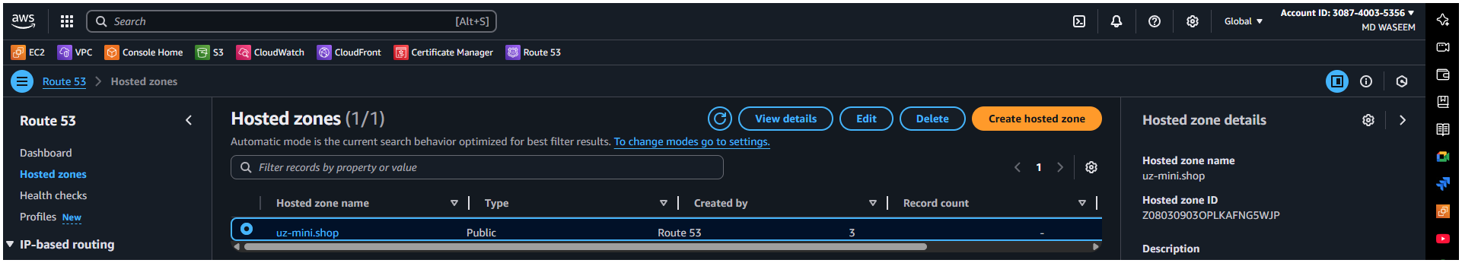  
🡪Add this NS {values/Routes traffic }

ns-497.awsdns-62.com

ns-879.awsdns-45.net

ns-1323.awsdns-37.org

ns-1636.awsdns-12.co.uk

------->copy this Name server name to your dns 🡪Name server  
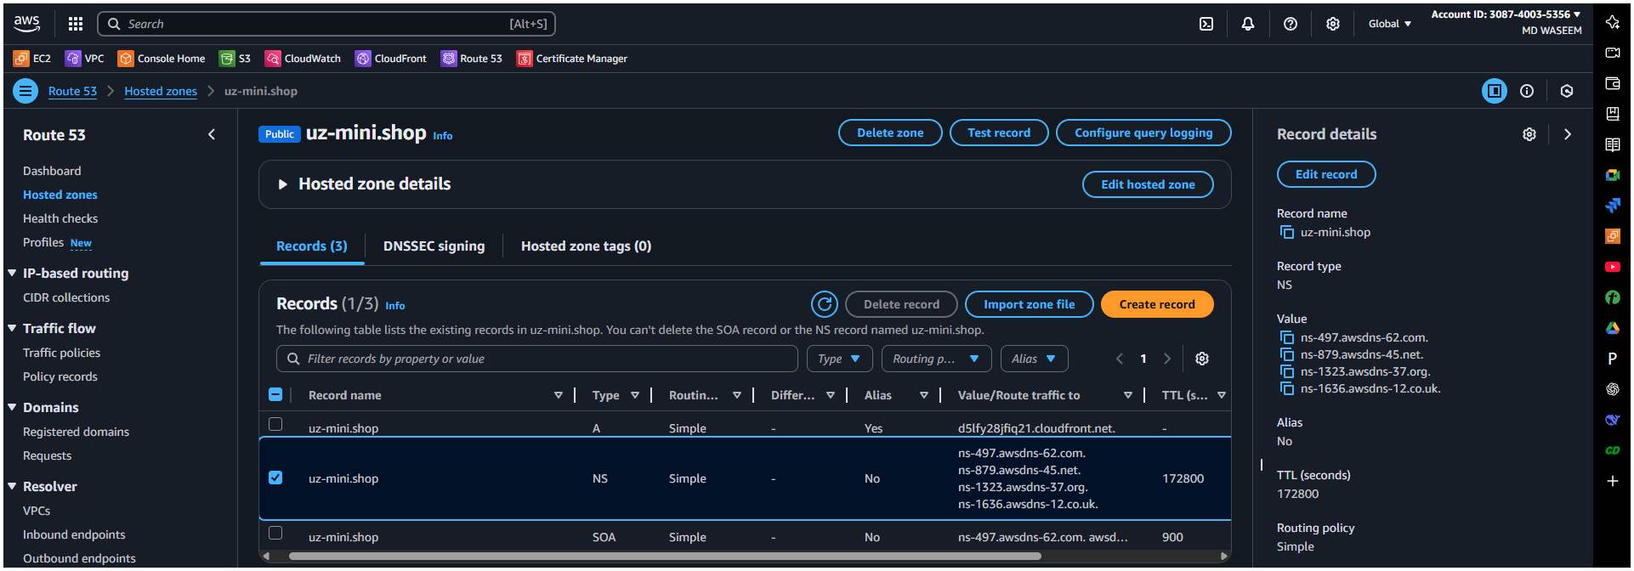

🡪Here we are Tab the setting tab from the my-product segment/option  
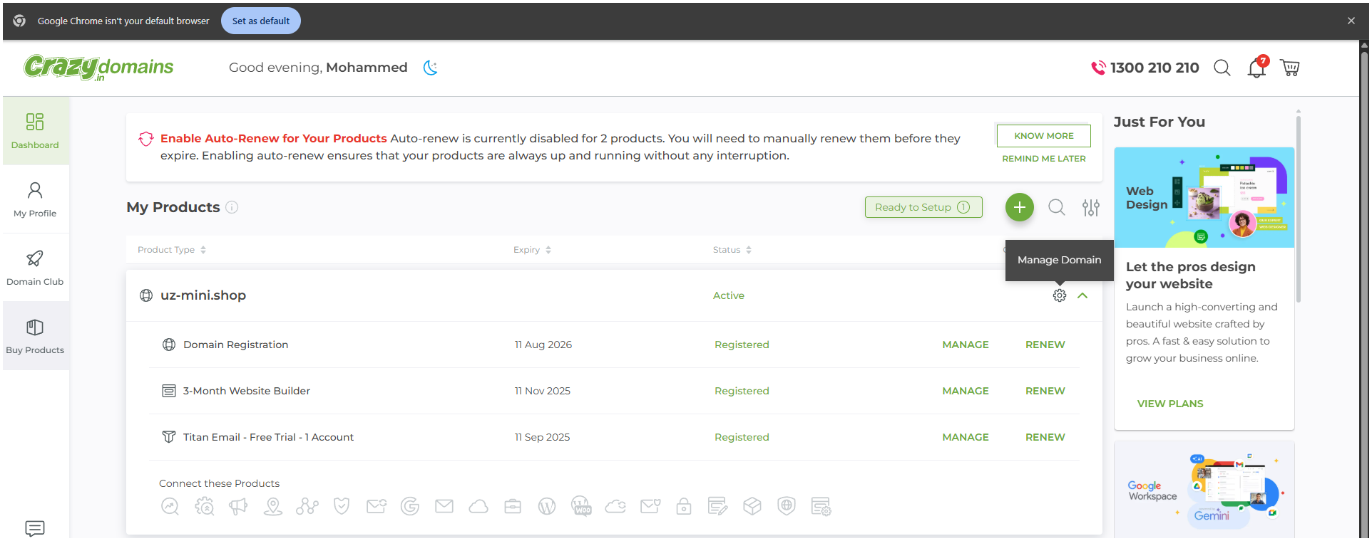

🡪 Here in Name servers select the 1st and click on the edit icon on the mid right

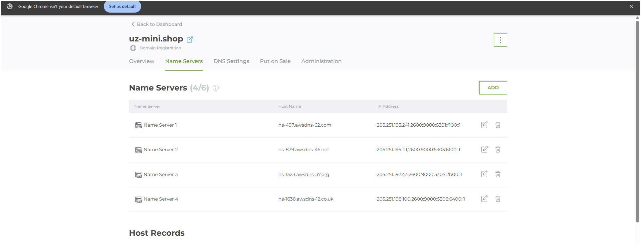  
🡪here we have add the Name server in Your Domain name {name server}  
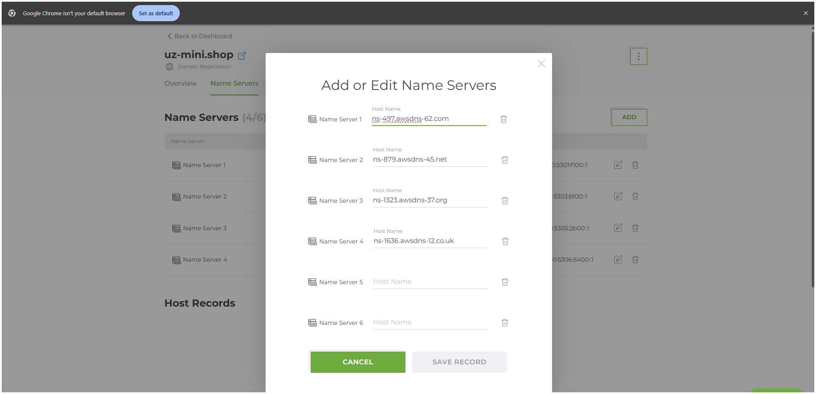

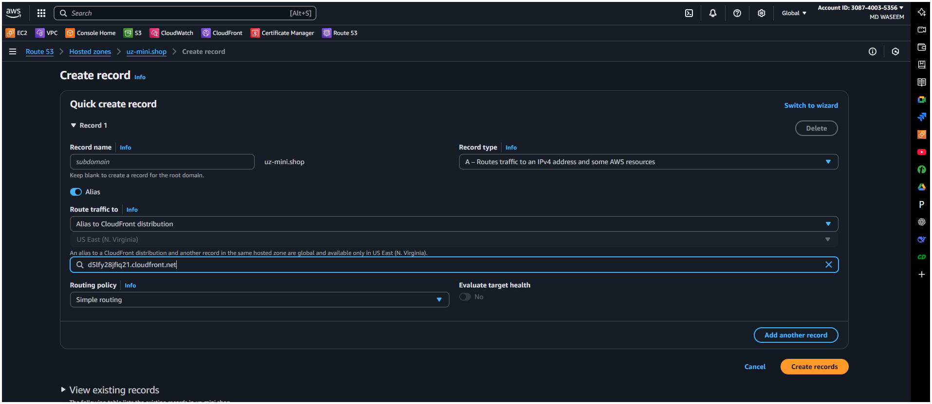

🡪 while adding the alternative and distribution from Cloud front  
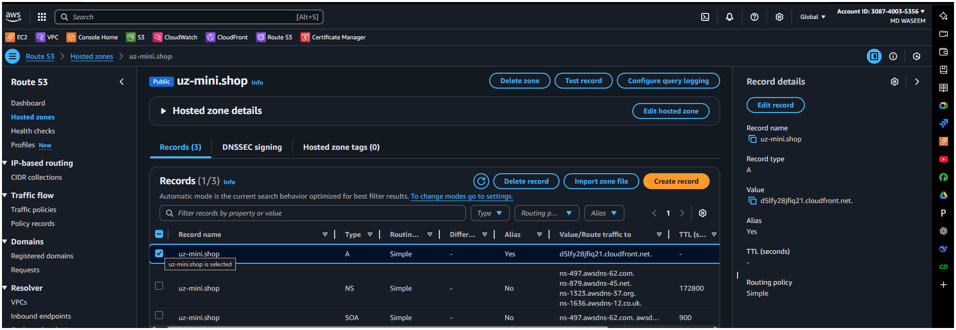

6) Update the index.html in s3 bucket and the updated file should be accessible by using domain name.

🡪old file of test.html  
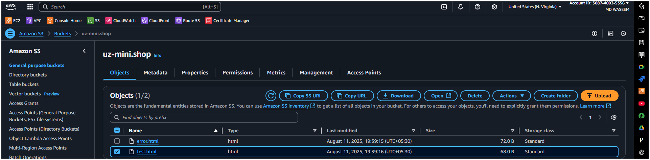  
🡪Run

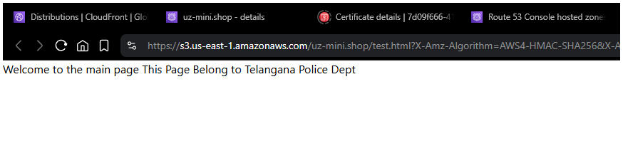

🡪Overriding the Old with New 🡪 Runed / Result

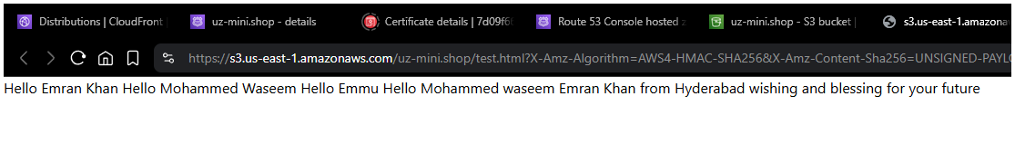

➤ In the CloudFront Console:

Go to your CloudFront distribution.

Click on the "Invalidations" tab.

Click "Create Invalidation".

In the Object Paths box, enter:

If you're not sure what changed or want to invalidate everything

Then simply add /*

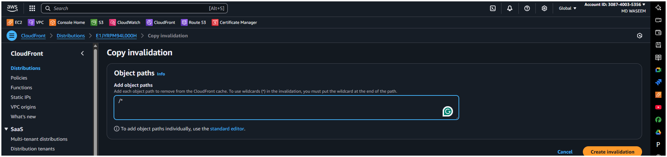

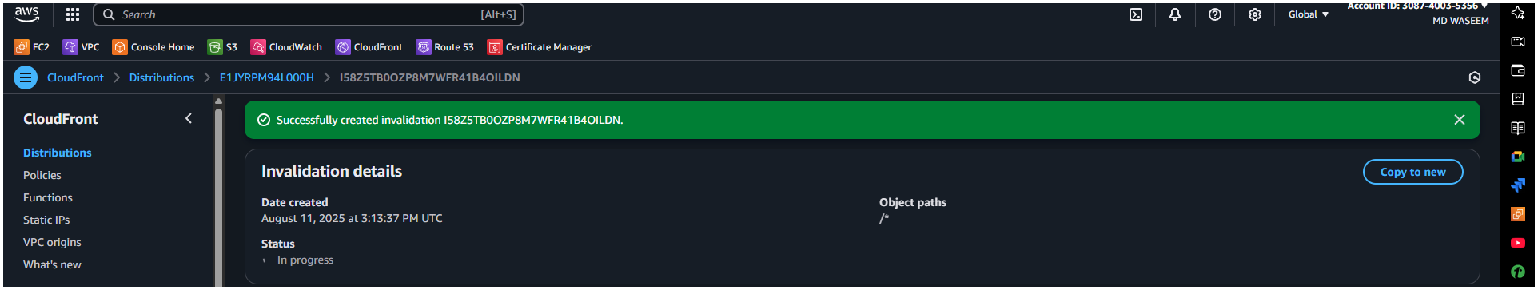

7) Share the Domain name in slack to test the connectivity.